WSN simulator and mobile sink optimization
Technical report
- Problem description:
We have a number of wireless sensors distributed in agriculture area
, those sensors are divided into groups, and in each group there is main sensor that all other sensors in the group send their data packets to it.
We consider each group as cluster, while the main sensor call him “cluster head”.
There are a number of mobile sinks travelling within the area to receive the data packets from the cluster heads, the mobile sinks move between a number of randivouz points.
We need to determine the optimal assortment for the clusterheads and the randivouz points in order to minimze the following costs where sensor may be called “node”
- energy consumption resulted from sending data from nodes to cluster heads
- energy consumption resulted from sending data from cluster head to RV points
- distribution of energy consumption among the node
- traveling time of mobile sink
- number of mobile sink

- optimization:
we used 4 MOO algorithms to accomplish the required:
- SC-MOPSO
- m-MOPSO
- MOPSO
- NSGA-II

- Optimization results:
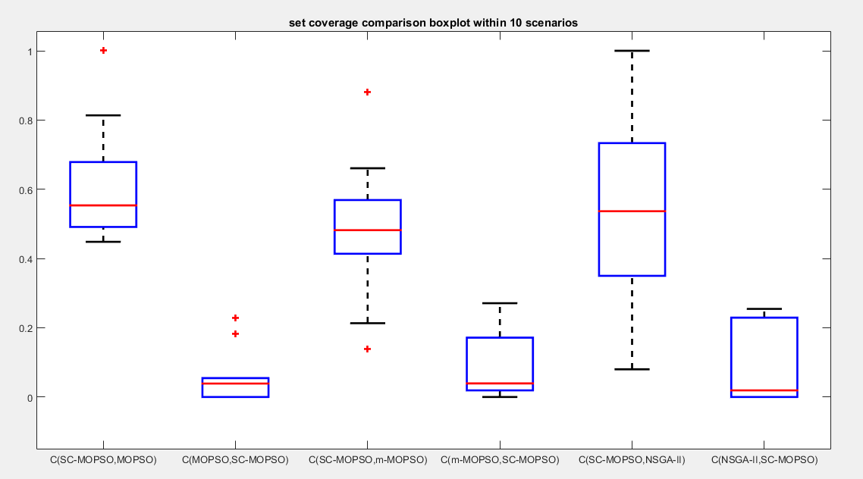

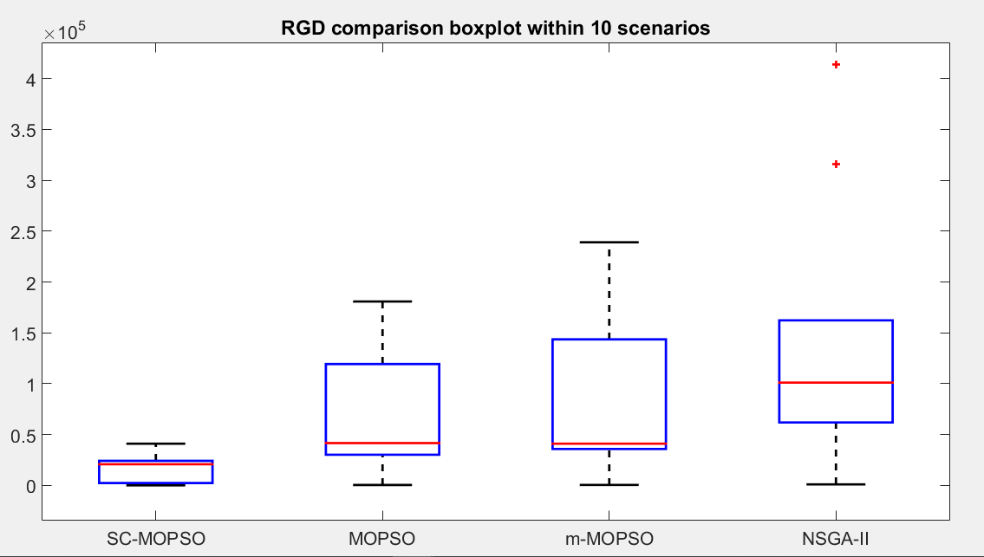

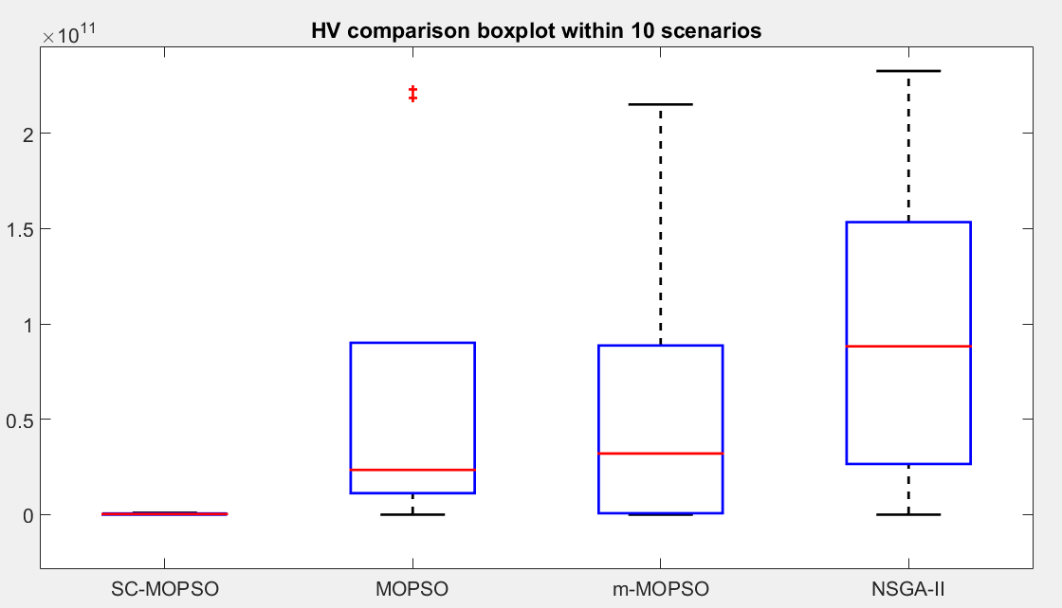
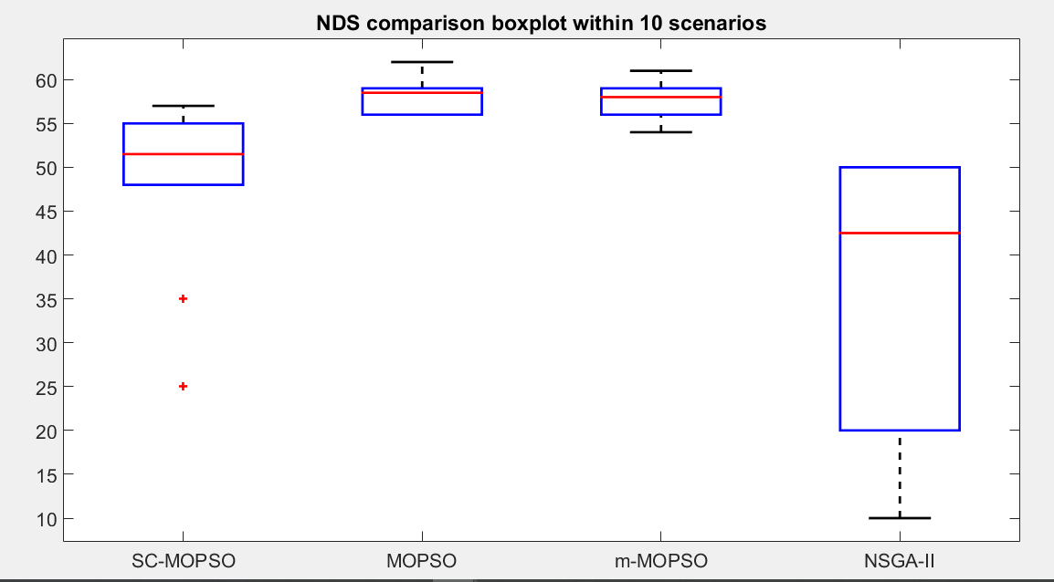

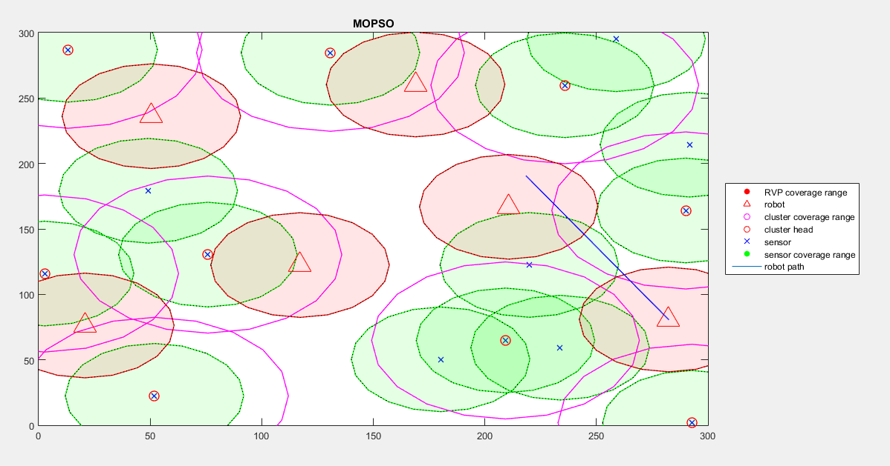
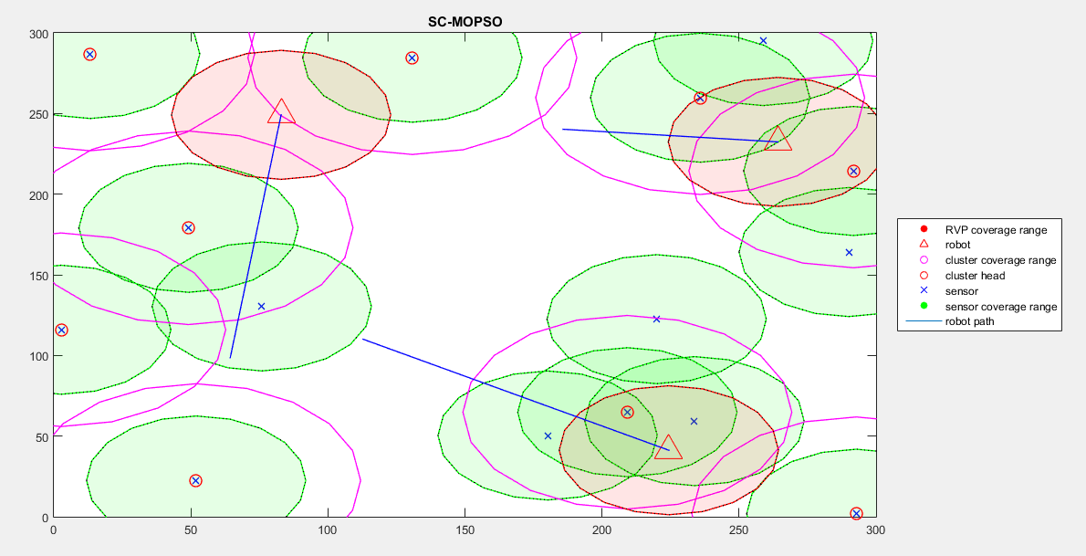

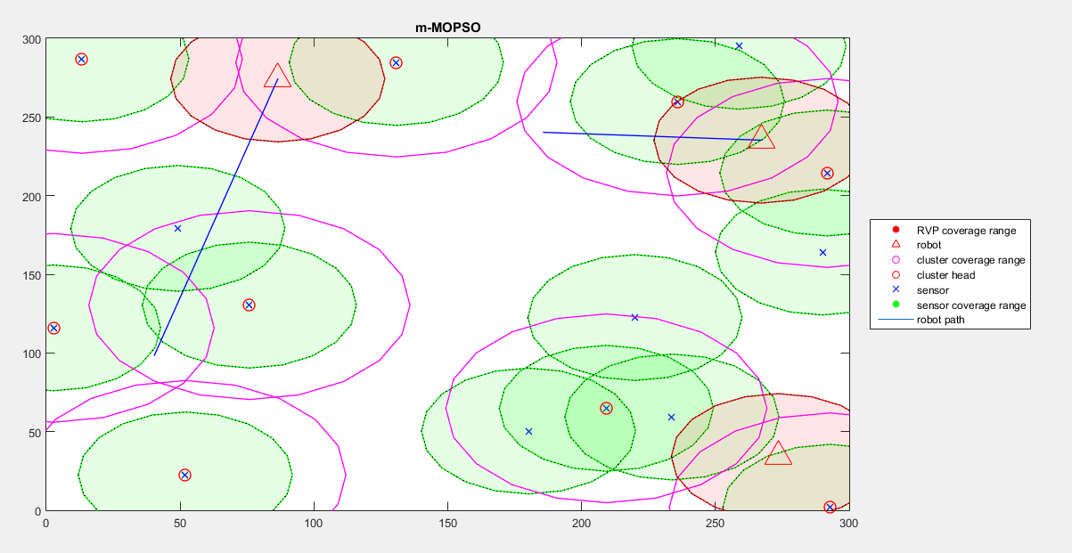

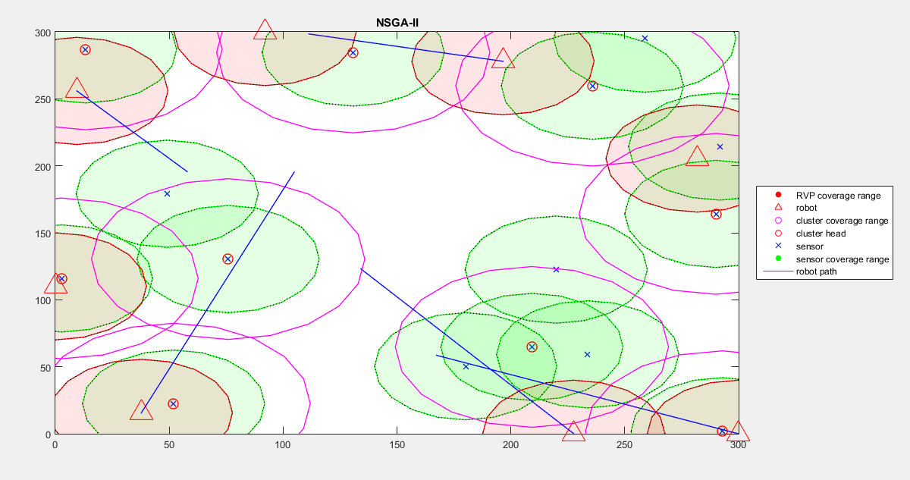

We notice that SC-MOPSO is superior in terms of SetCoverage, RGD, but is less superior in terms of NDS and HV.
And by visualize some solutions from the paretoFronts, we notice that SC-MOPSO and m-MOPSO have introduced the optimal solution with the lowest cost (number of mobile sinks).

- Simulation:
We need a WSN simulator to approve that SC-MOPSO is the superior in terms of communication performance.
4-1 simulator building:
we have built our own WSN simulator for simulate the optimization results
4-2 simulator interface
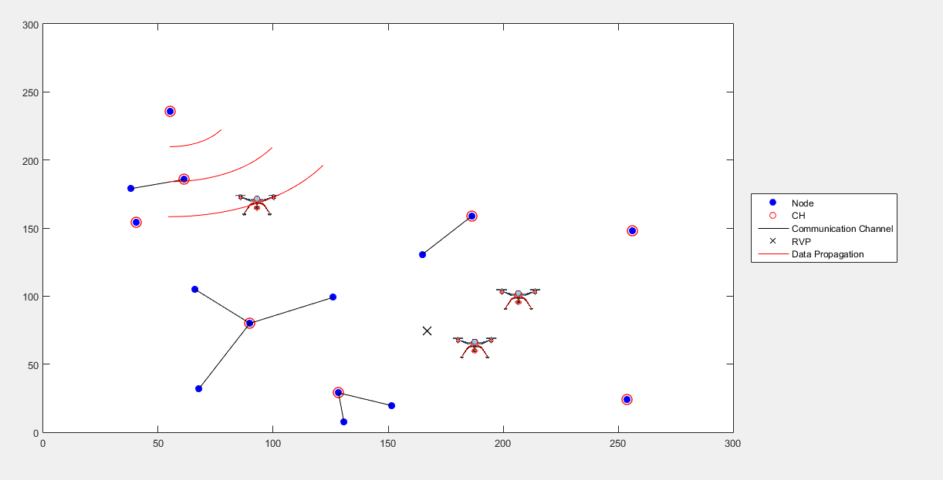

4-3 simulation parameters:
timeUnit: 10 ms
experiment time: 100 s
robot velocity: 10 m/s

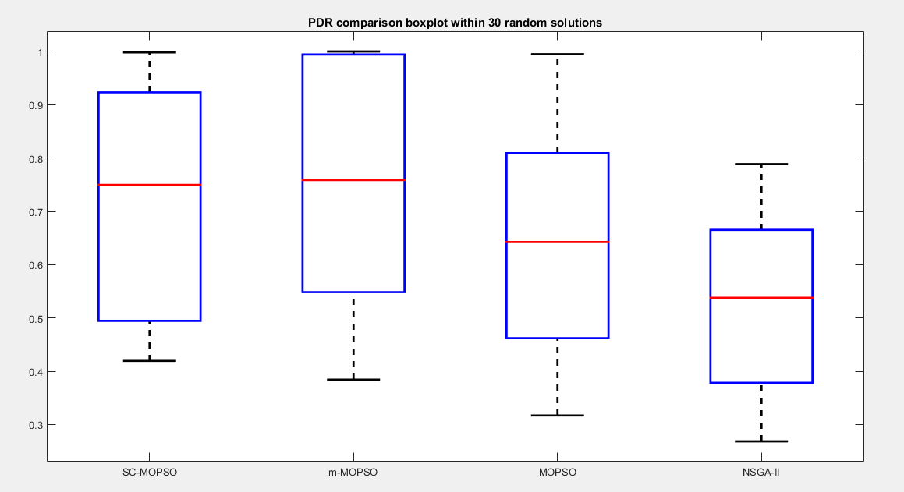
4-3 communication performance:

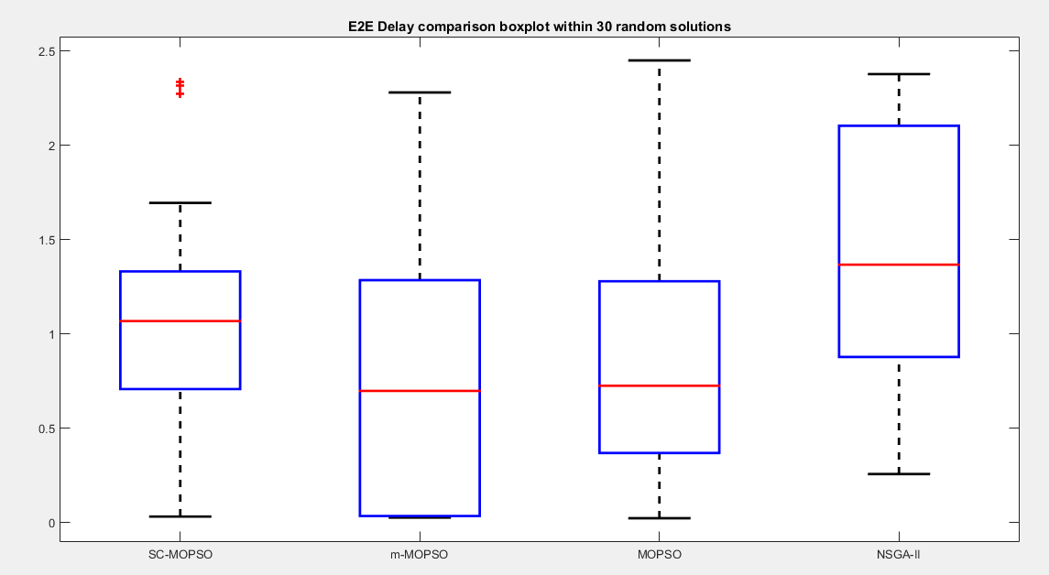
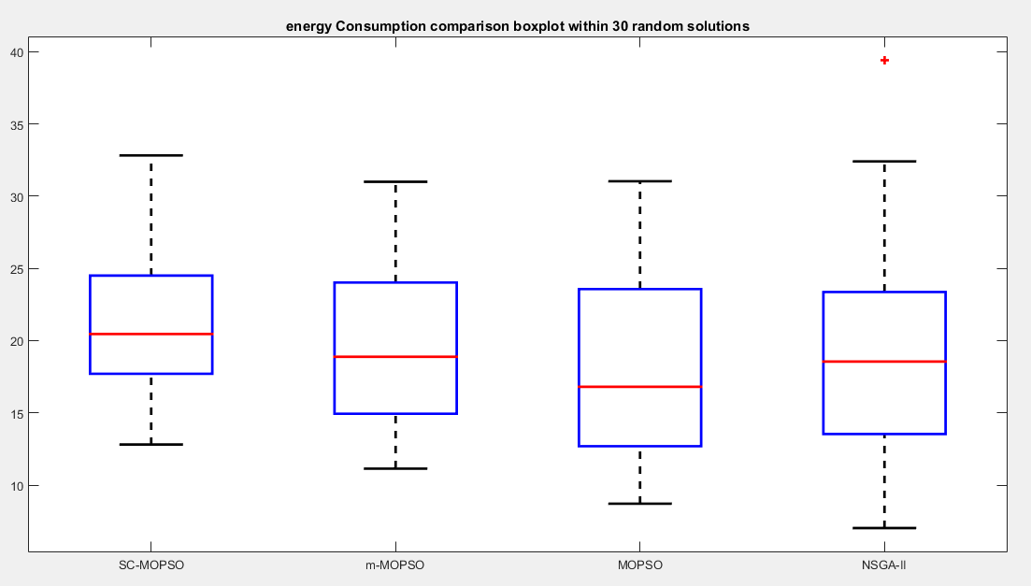

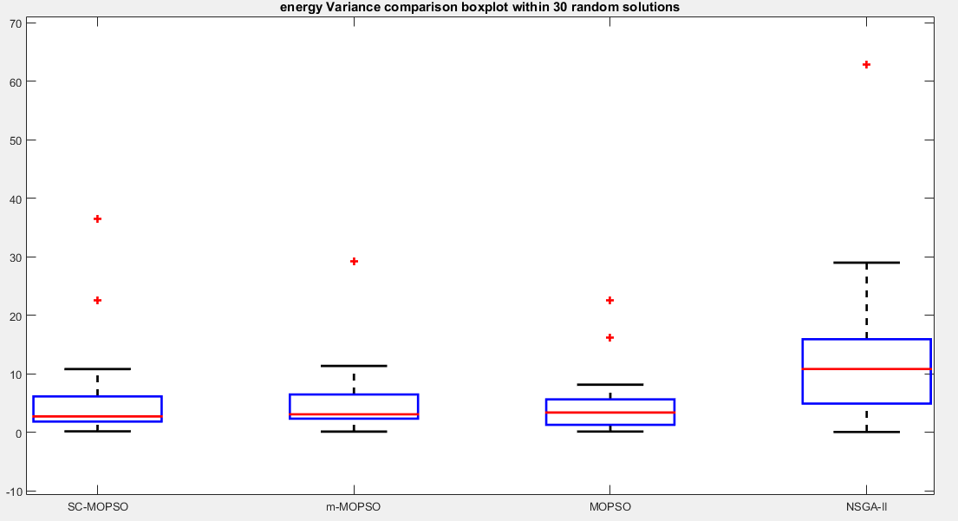

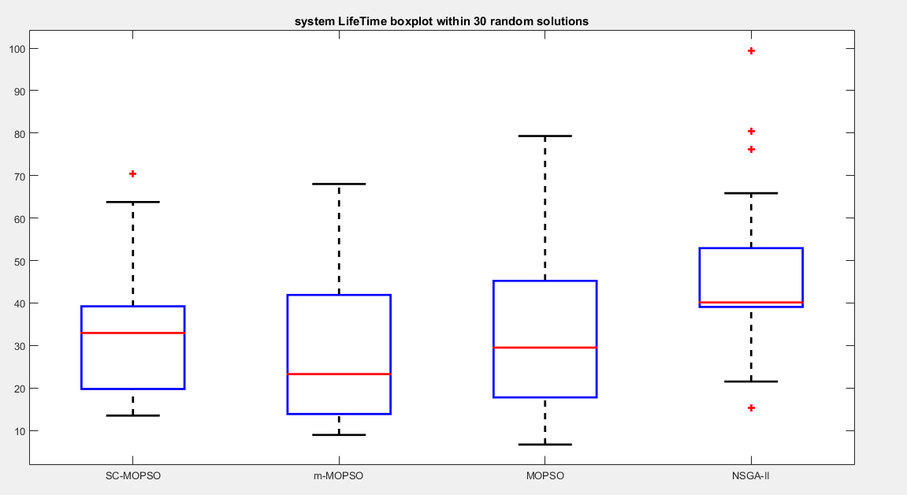
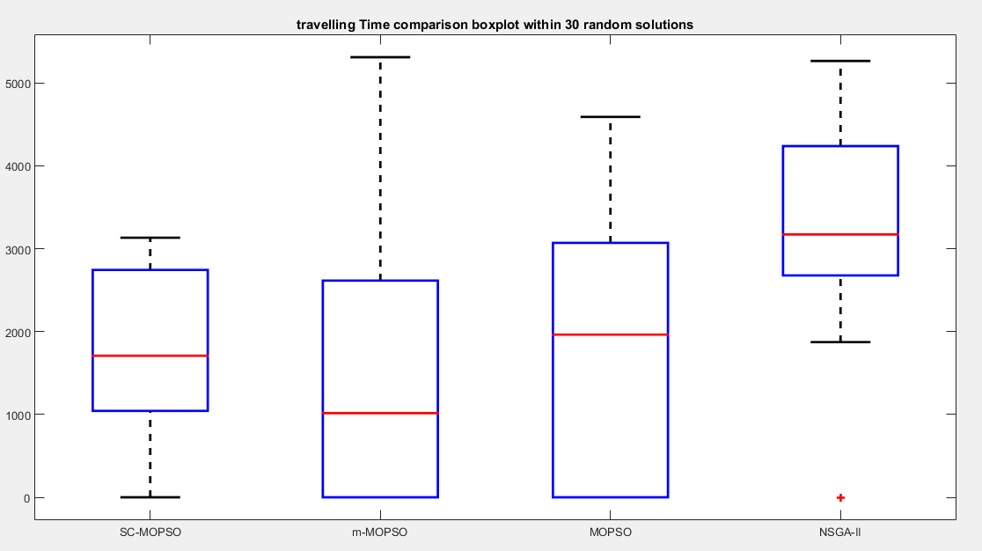

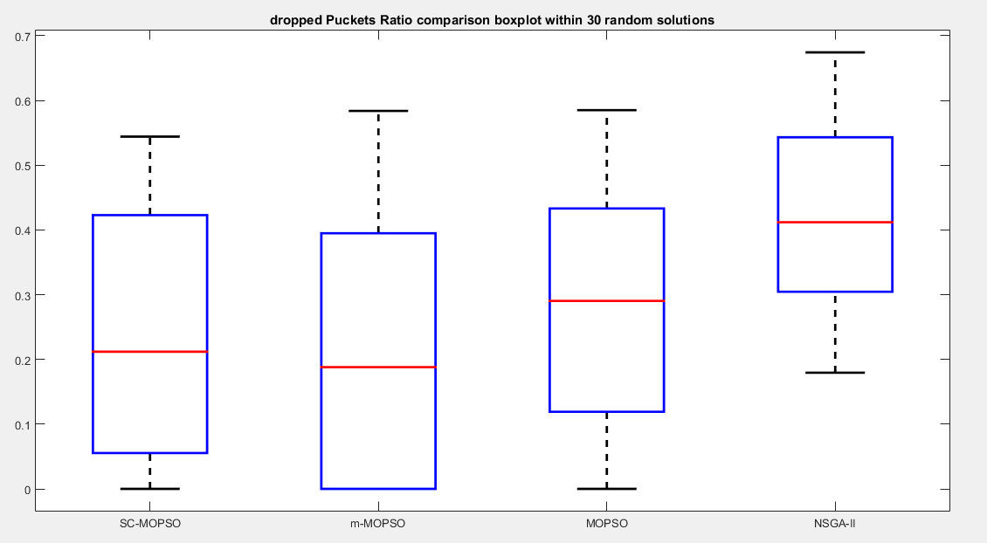

4-4 comparison summary:
PDR  (from best to worst) | Dropped Ratio  (from best to worst) | E2E Delay  (from best to worst) | Travelling time  (from best to worst) | Energy consumption  (from best to worst) | Energy  Vaiance  (from best to worst) | System Life time  (from best to worst)
m-MOPSO | m-MOPSO | m-MOPSO | m-MOPSO | MOPSO | SC-MOPSO | m-MOPSO
SC-MOPSO | SC-MOPSO | MOPSO | SC-MOPSO | NSGA-II | m-MOPSO | MOPSO
MOPSO | MOPSO | SC-MOPSO | MOPSO | m-MOPSO | MOPSO | SC-MOPSO
NSGA-II | NSGA-II | NSGA-II | NSGA-II | SC-MOPSO | NSGA-II | NSGA-II

- We notice that the optimization results don’t agree with the simulation results.
- And the reasons are the following:
- the main resaon Is that the communication performance measures don’t consider the cost of using multi mobile sinks, and SC-MOPSO have the least costs of mobileSinks number in its paretoFront, and despite the difference between the solutions costs, SC-MOPSO has almost been the best after m-MOPSO.
- Since SC-MOPSO has lower number of mobile sinks, then the mobile sinks will travel between more than one randivouz point, so the travelling time will be bigger and the cluster heads will not can send their packets if the mobile sink is not located in the randivouz point, resulting bigger E2E delay , and since the packet has a life time , it may be dropped after some waiting time, resulting smaller PDR, and lower number of mobile sinks means that the cluster heads will send the packets witgin longer distance, resulting more energy consumption.

- So, we need to compare between m-MOPSO and SC-MOPSO using solutions have the same costs.
- So we have run the simulator in the following cases

- Case: 2 mobile sinks
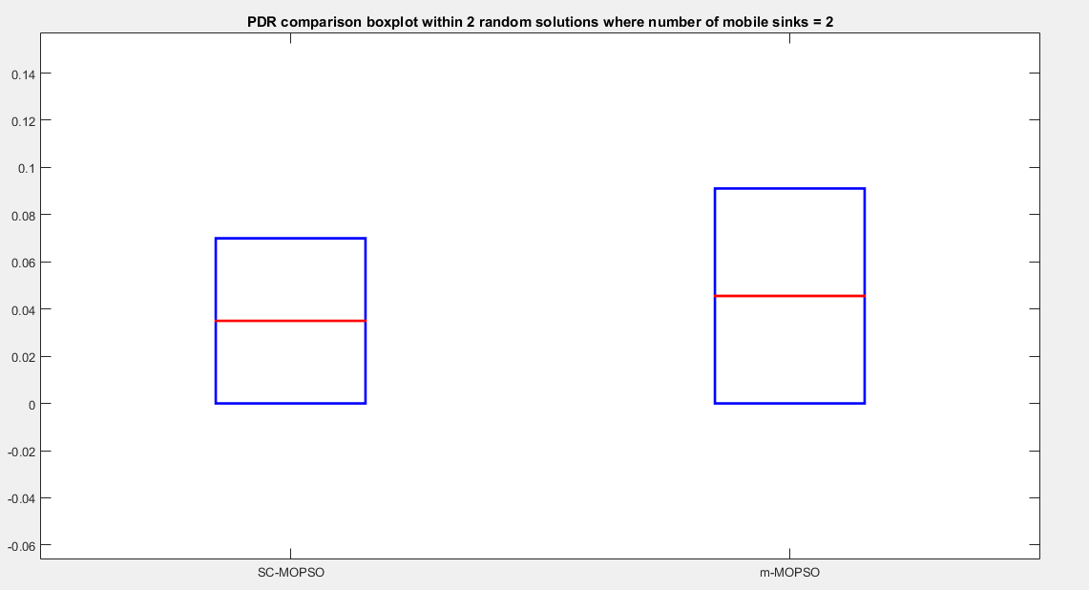

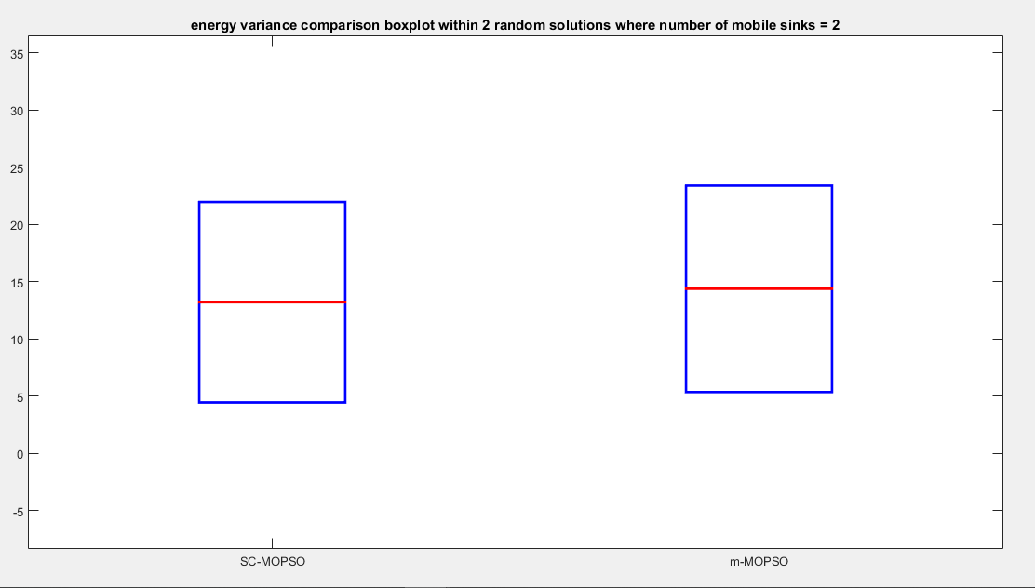
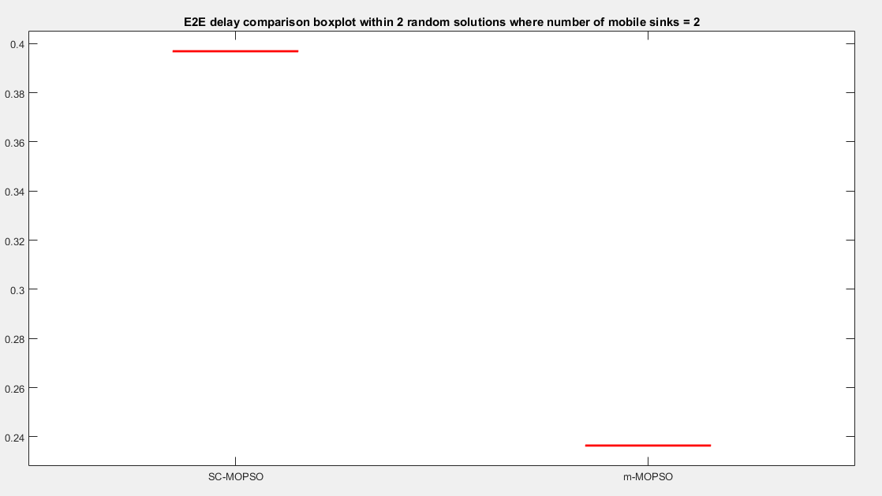

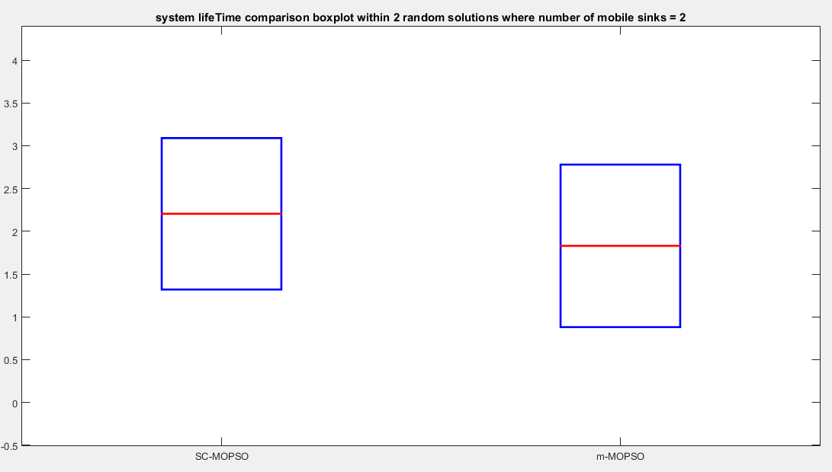
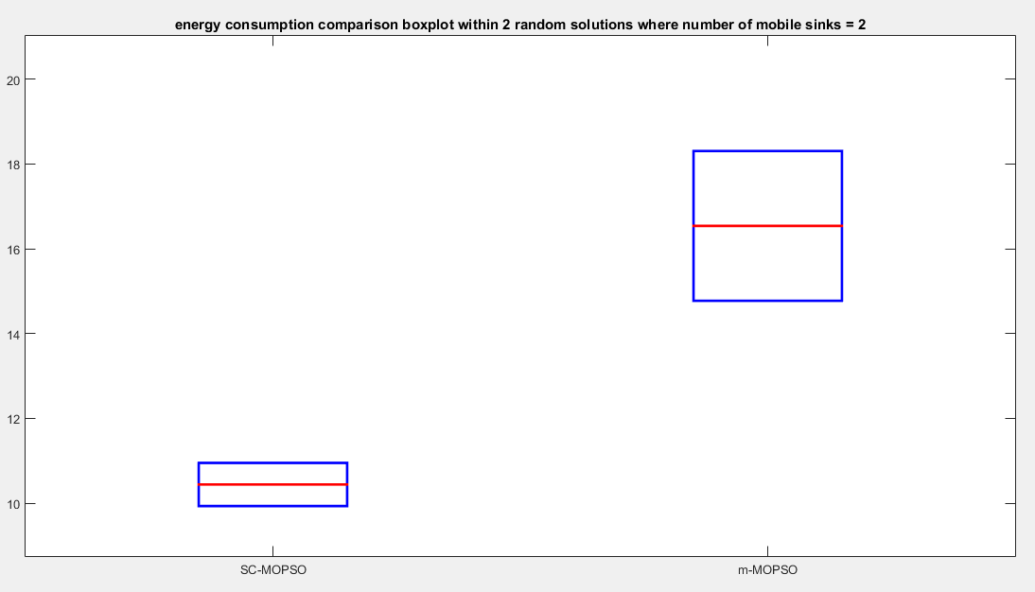

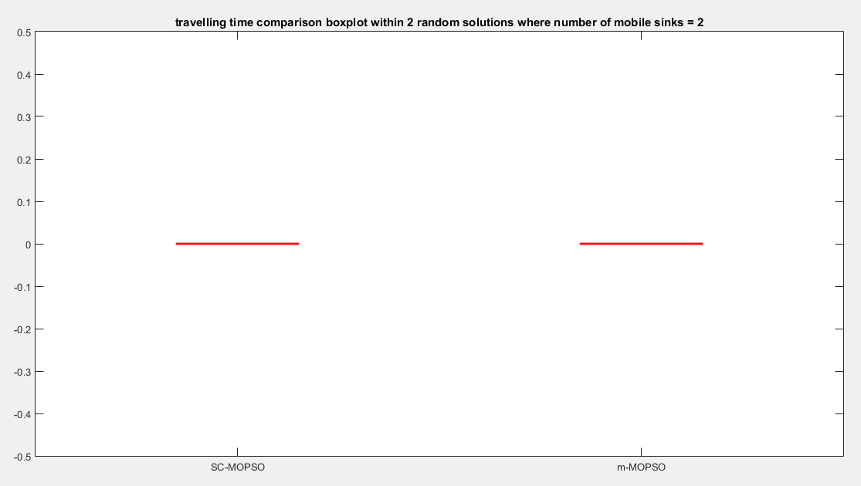
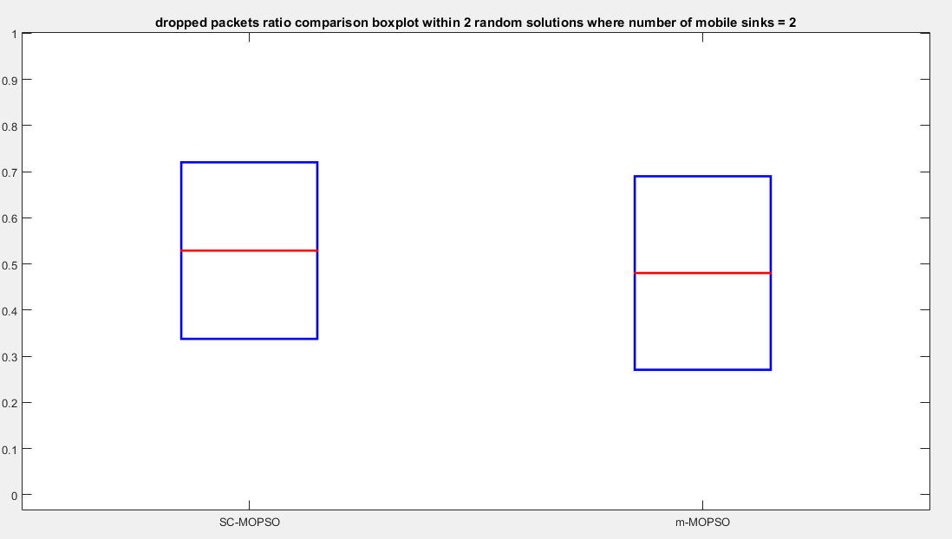

- Case: 3 mobile sinks
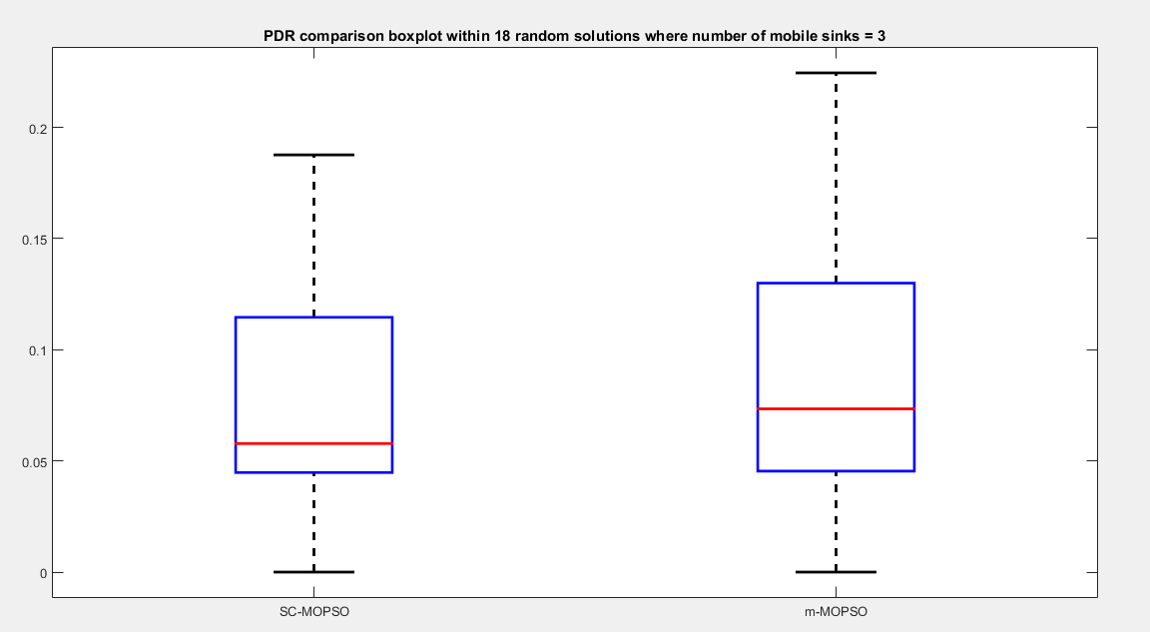
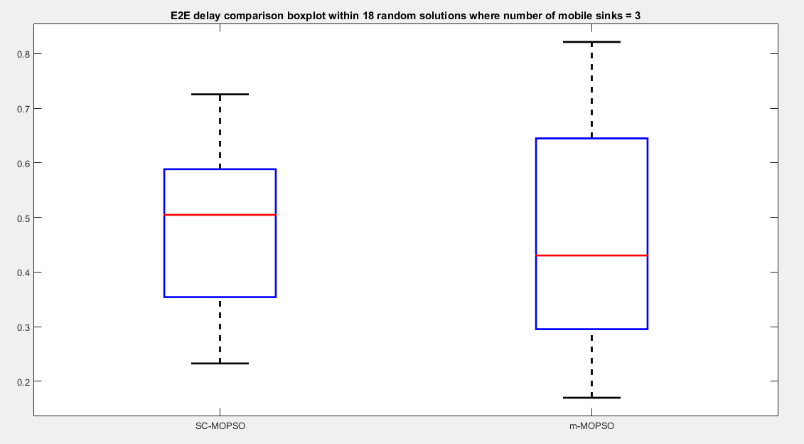

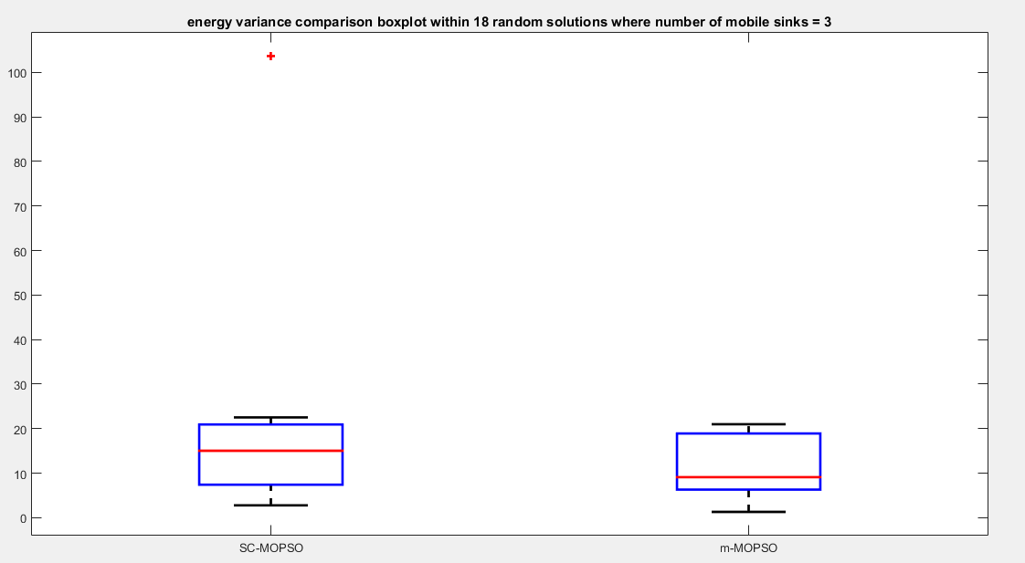
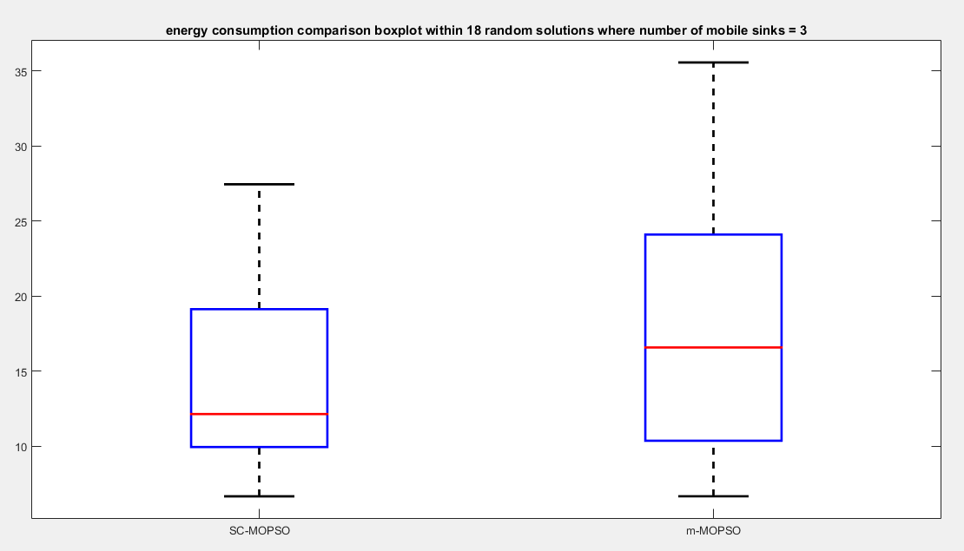

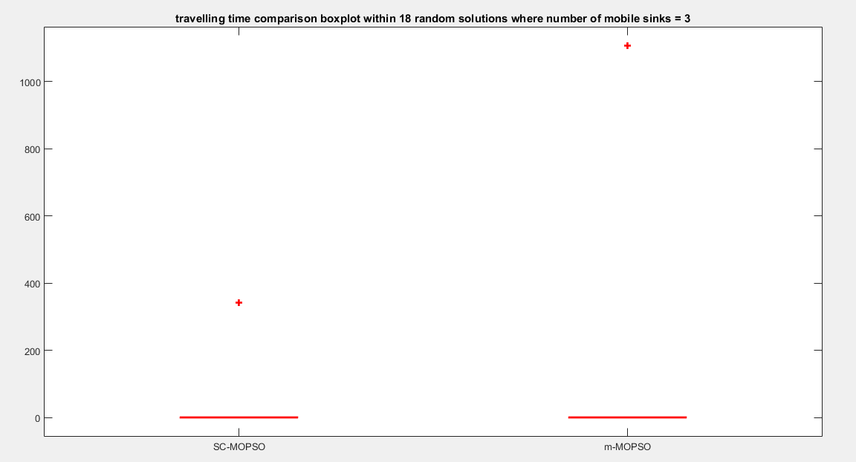
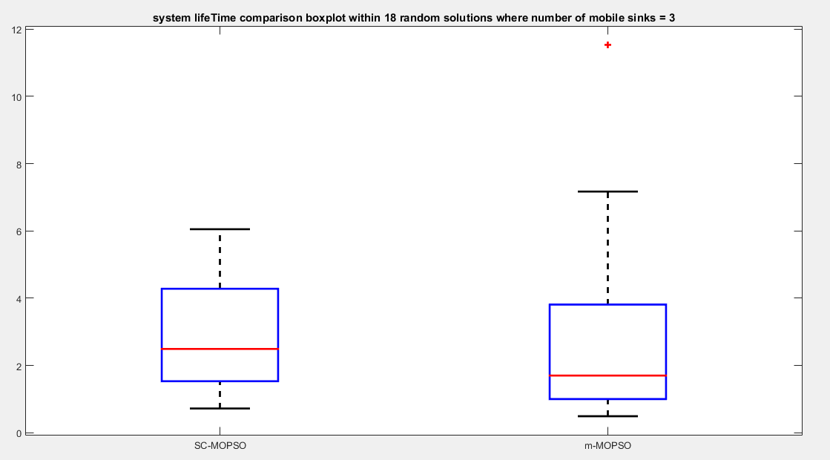

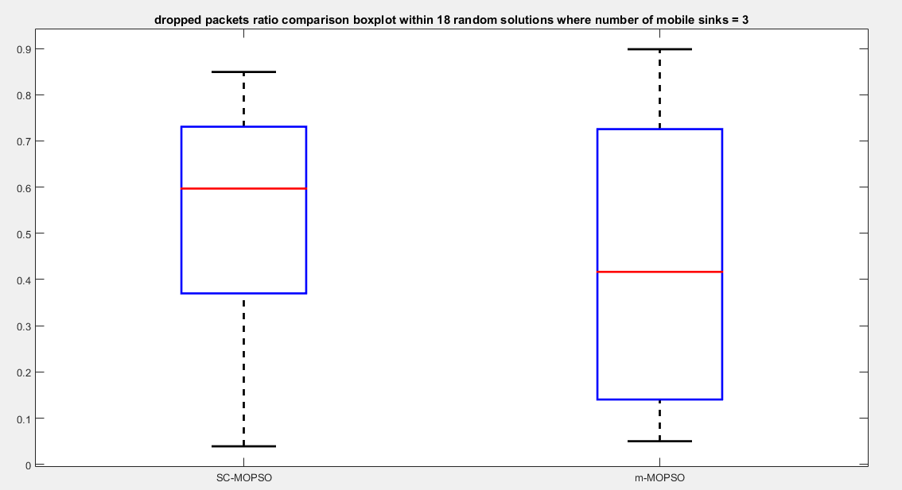
- Case: 4 mobile sinks
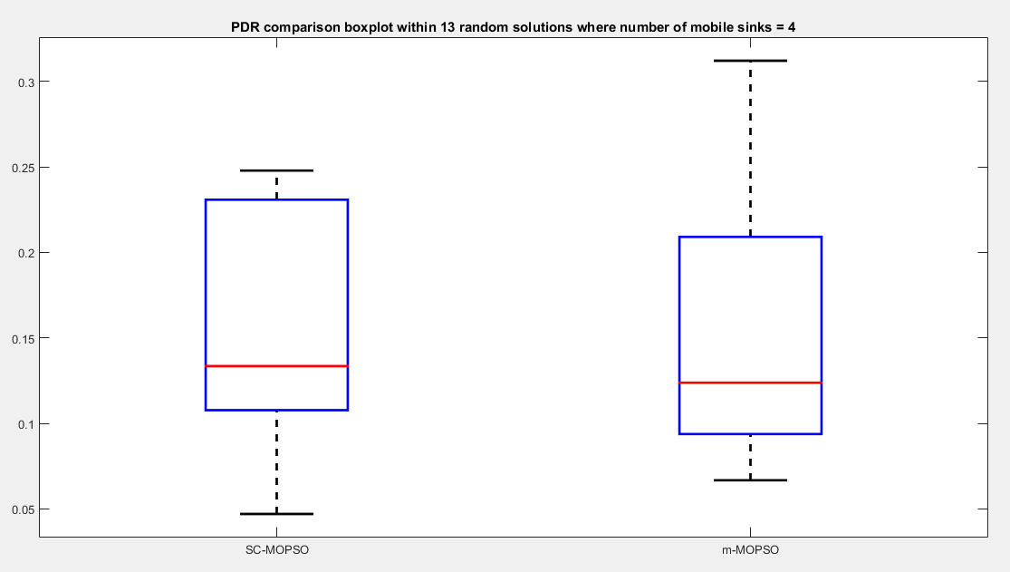

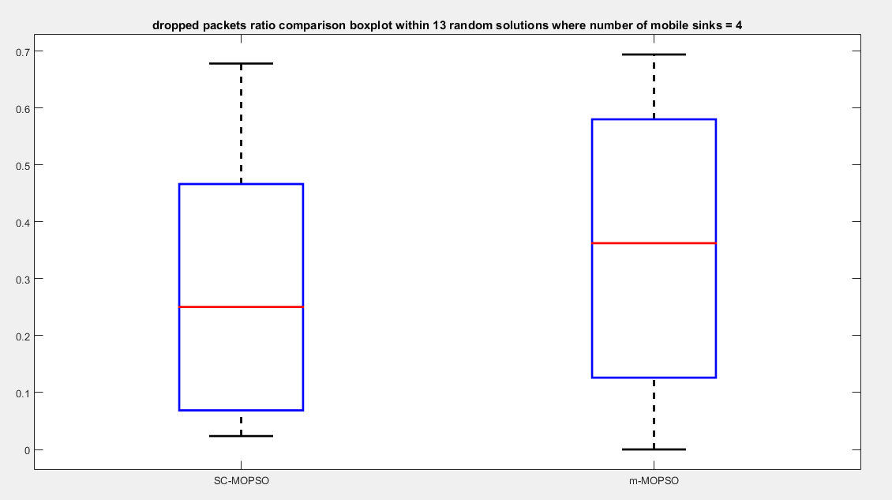
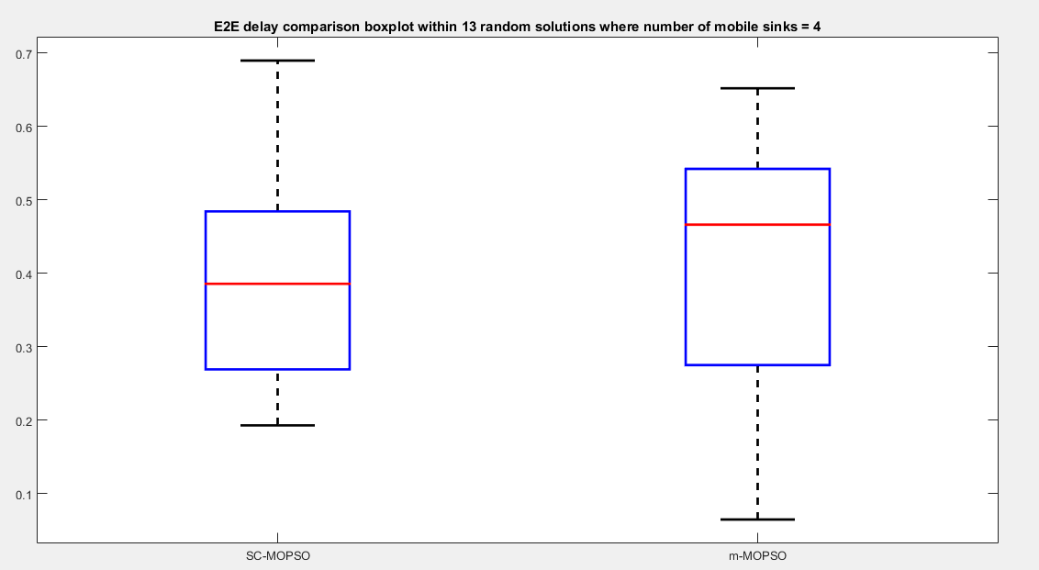

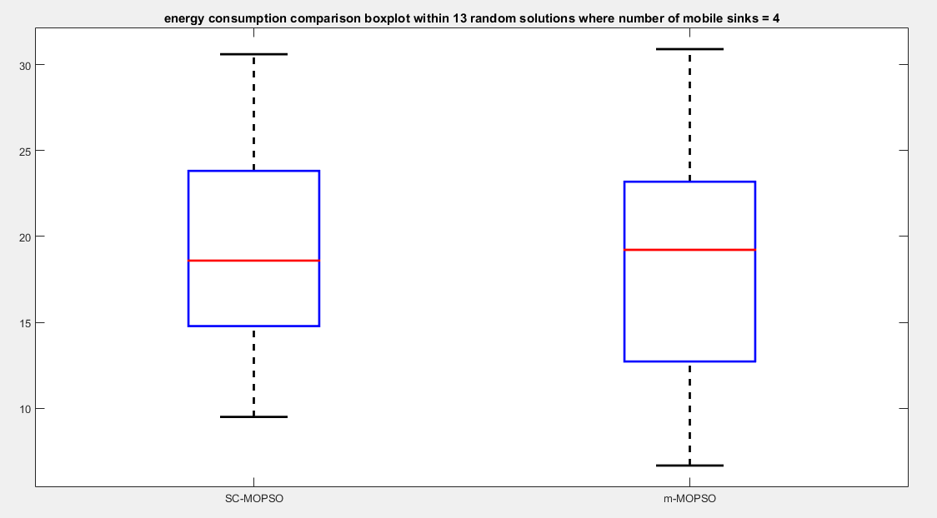
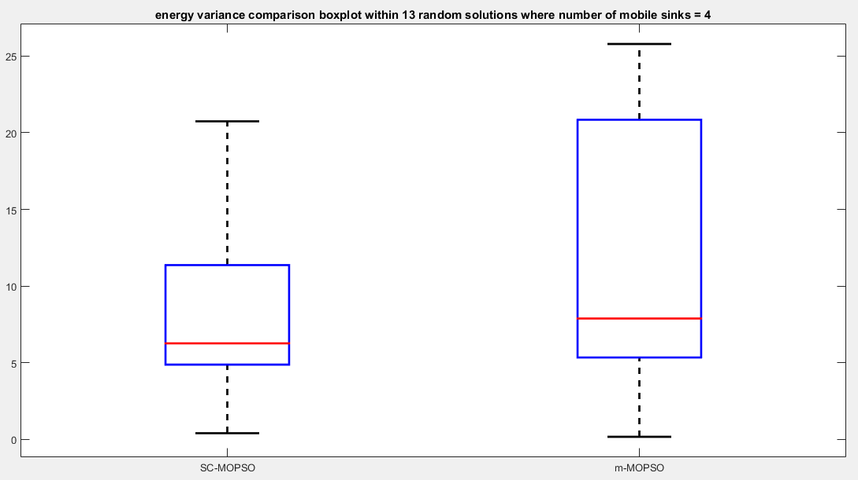

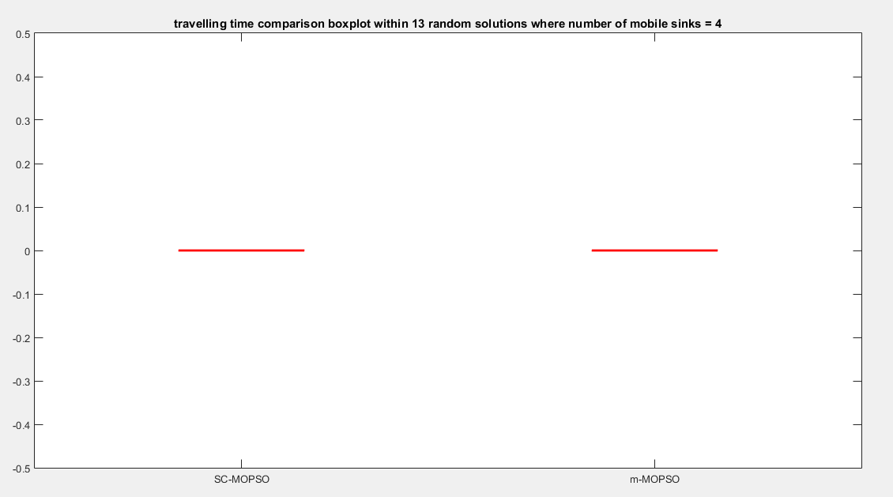
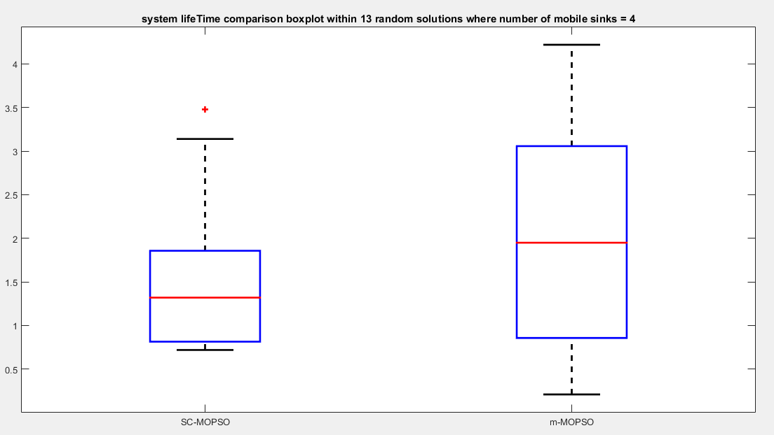

- Case: 5 mobile sinks
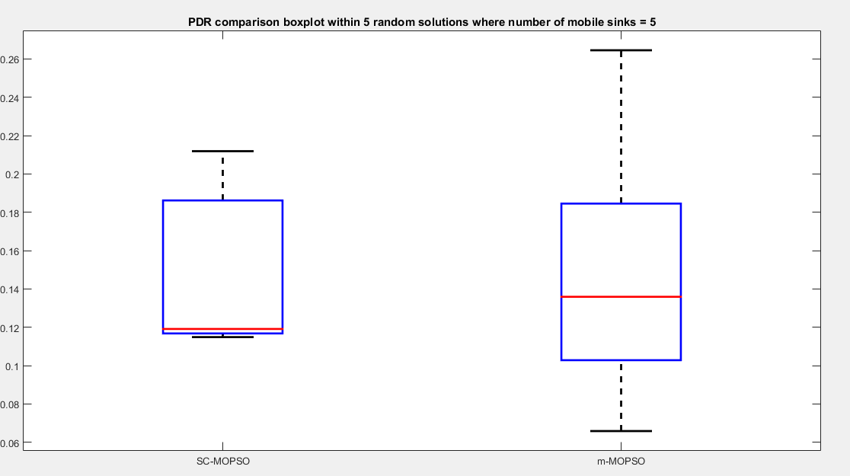
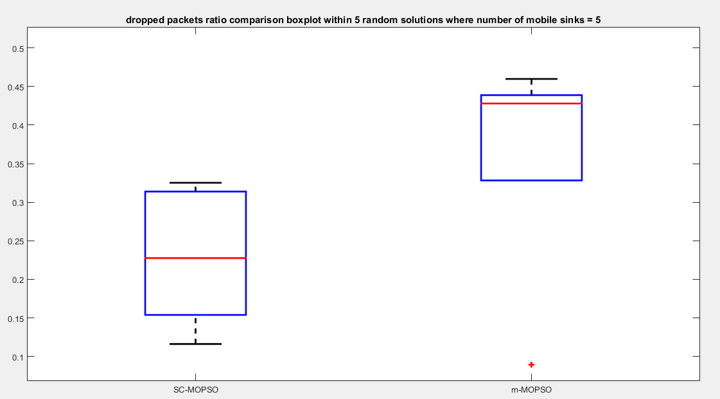

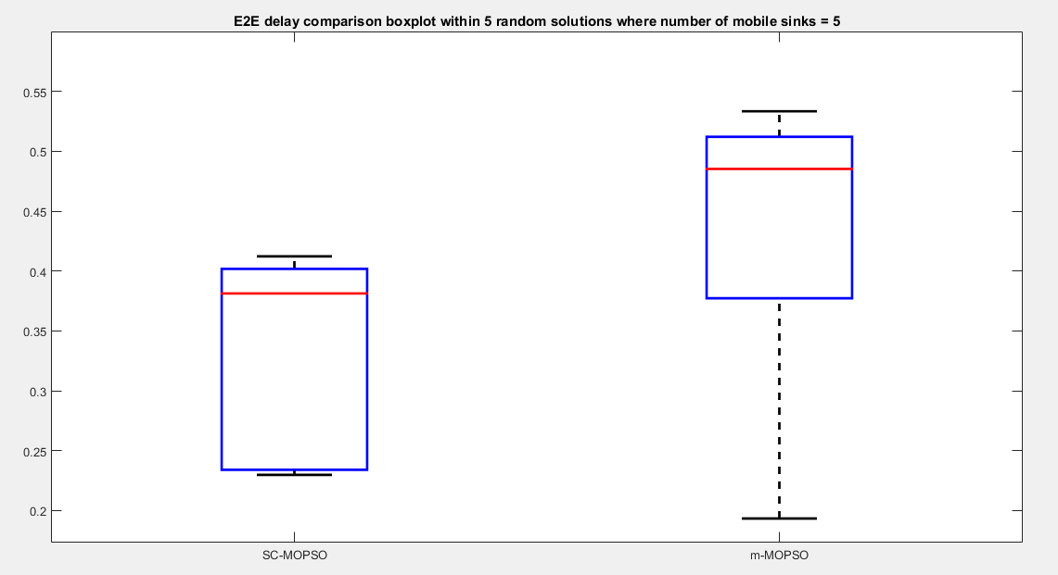

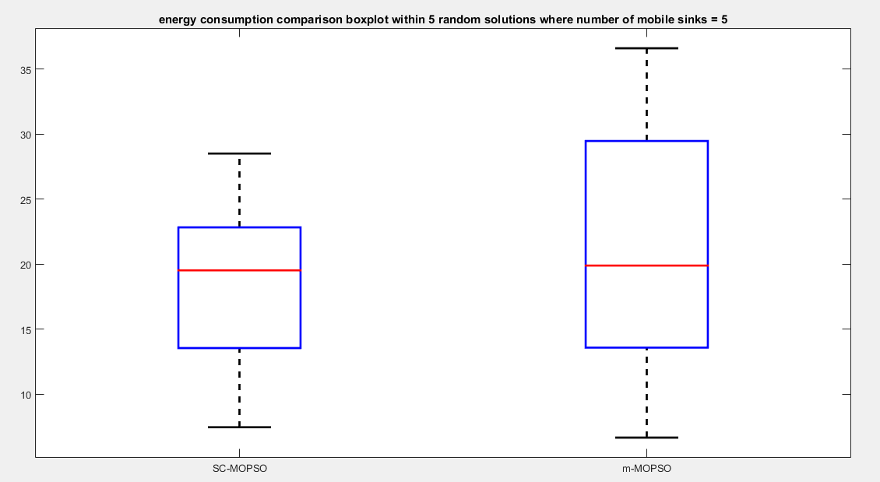

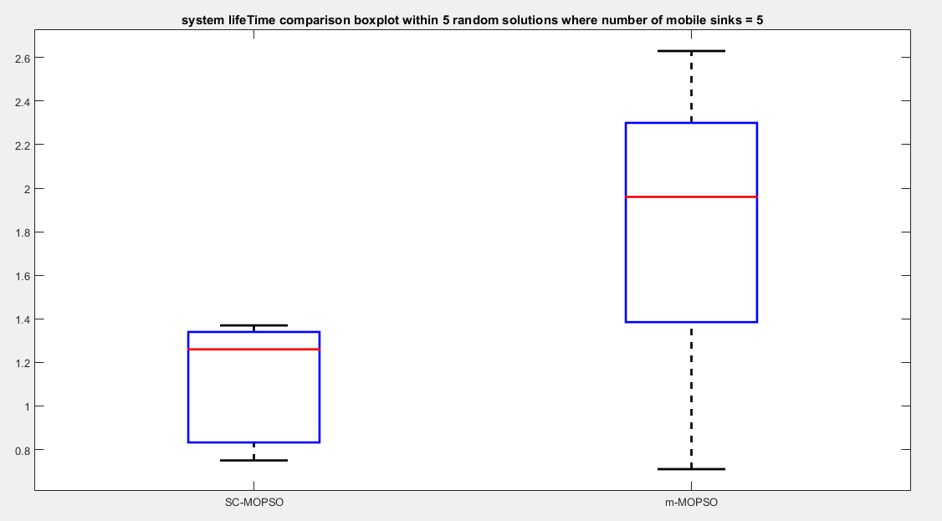
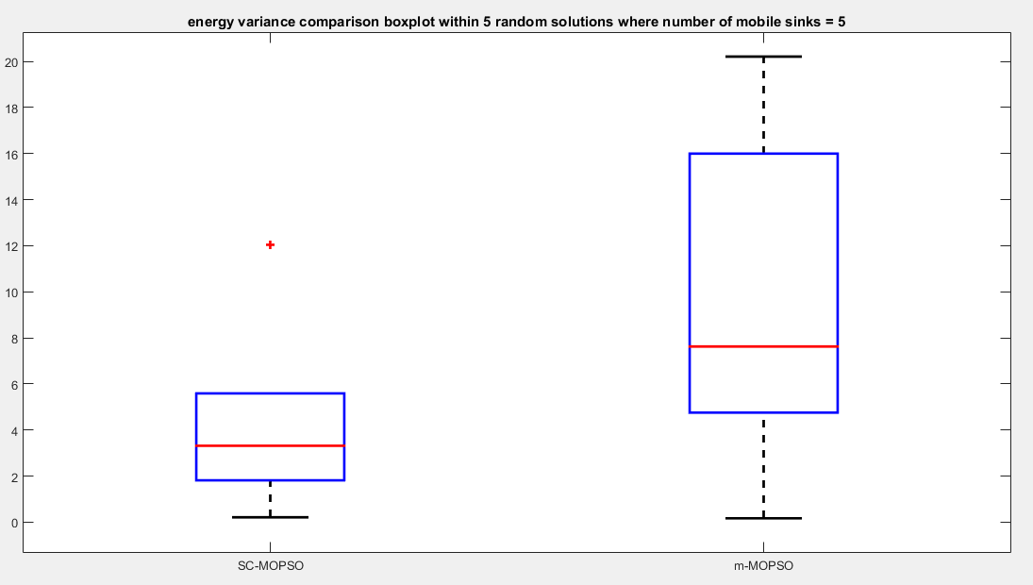

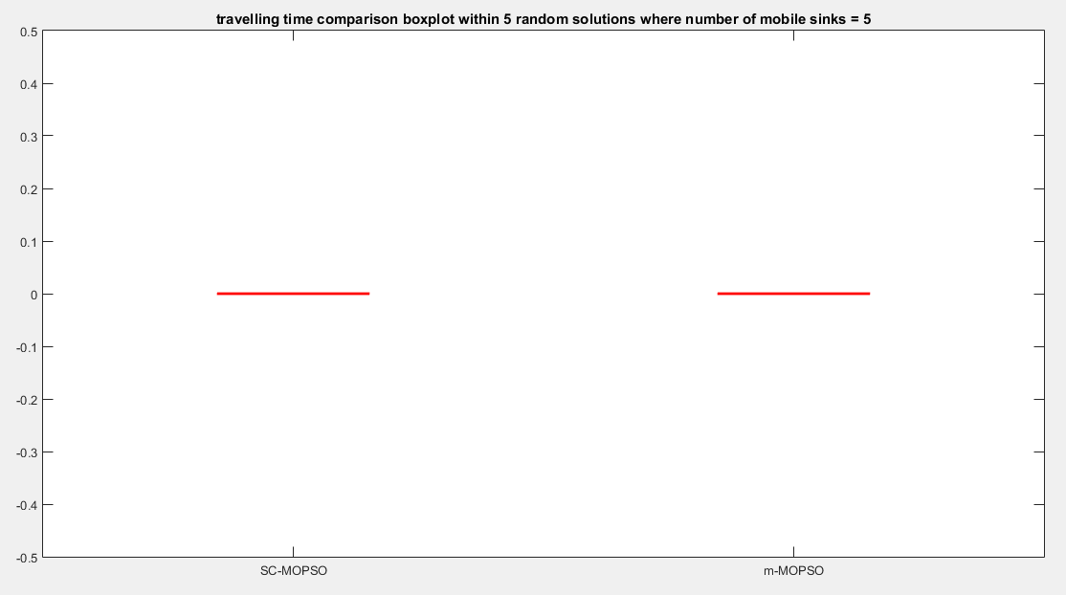

- Case: 6 mobile sinks
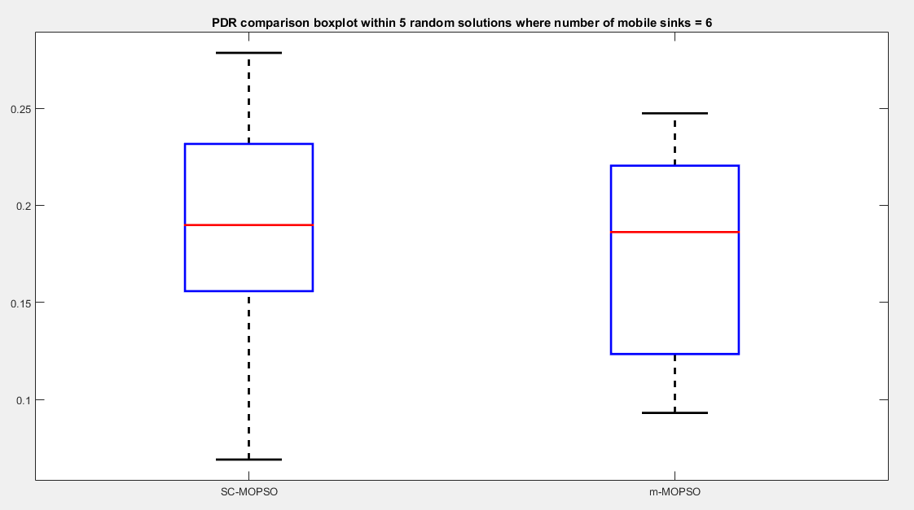
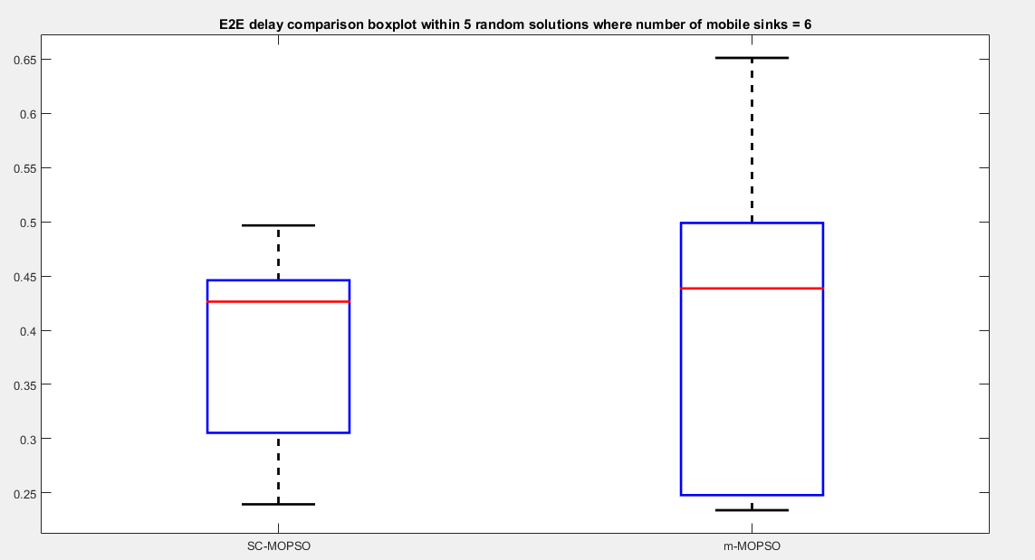
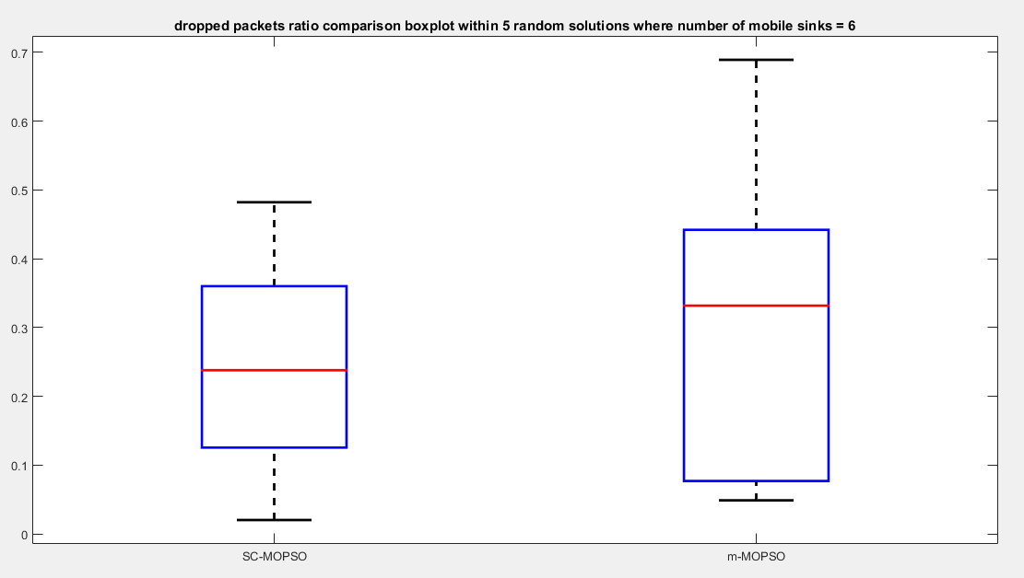

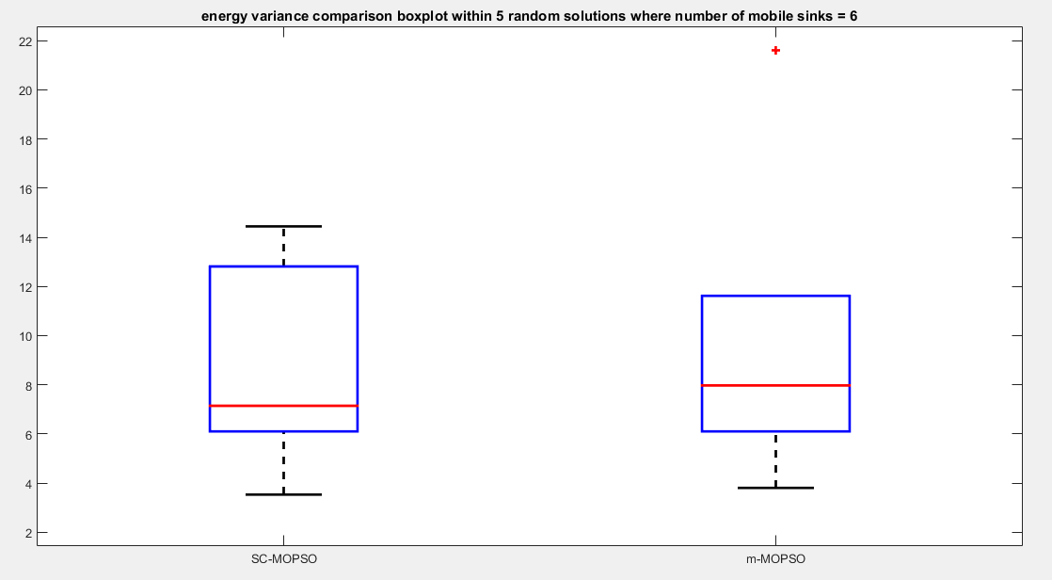
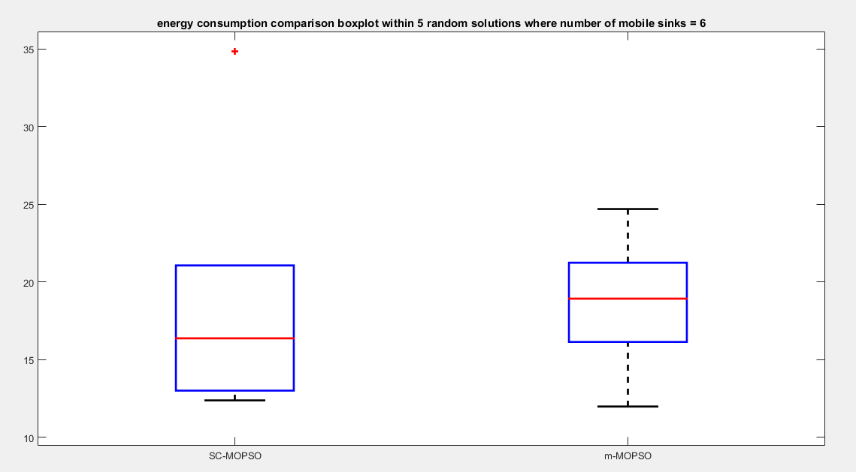

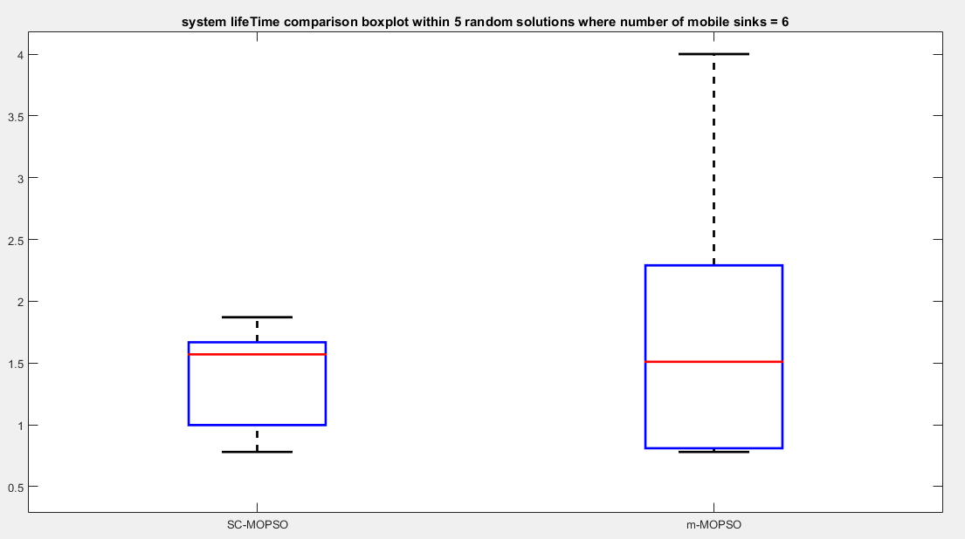
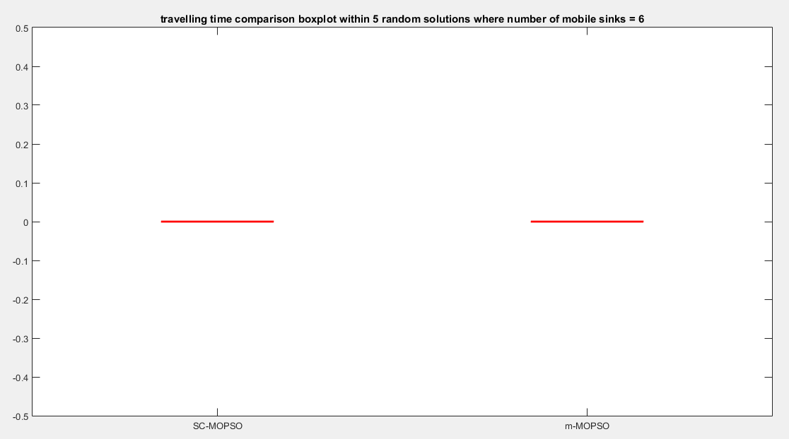

- Case: 7 mobile sinks
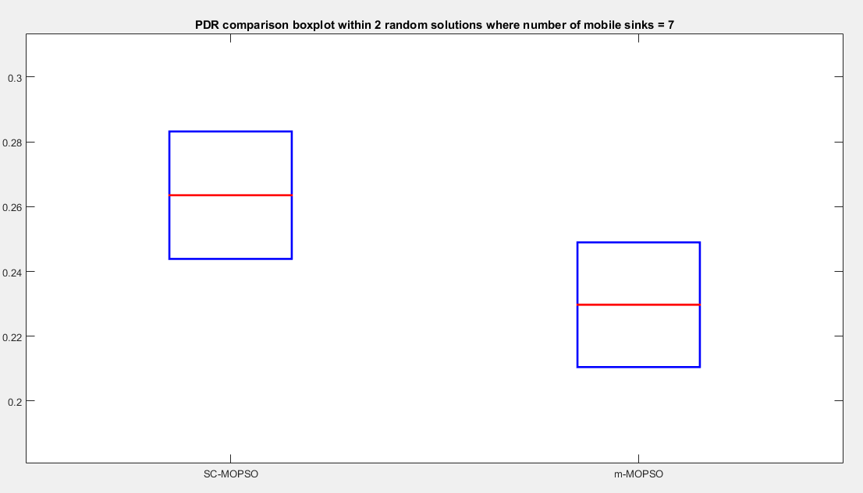
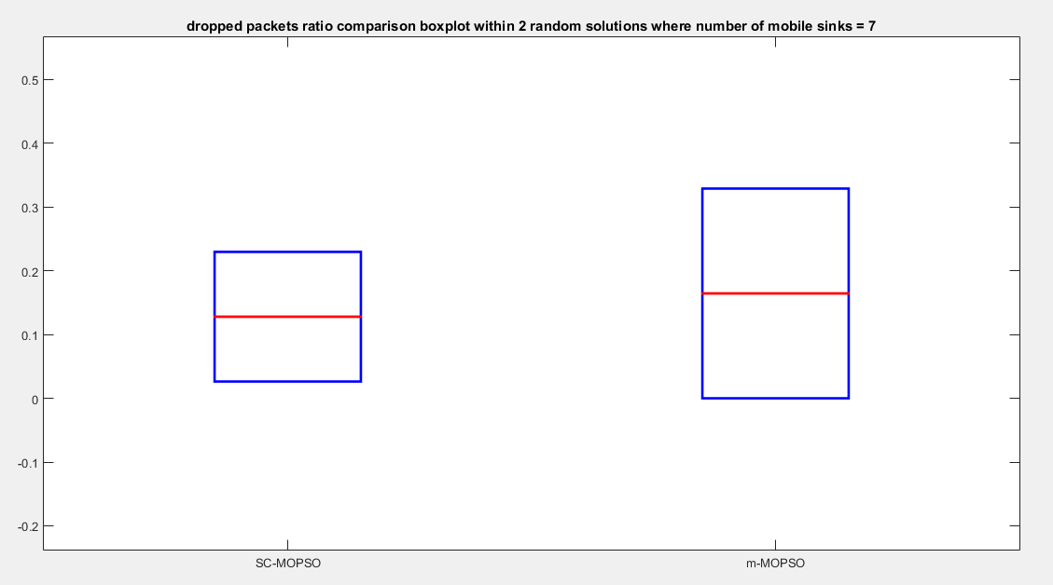

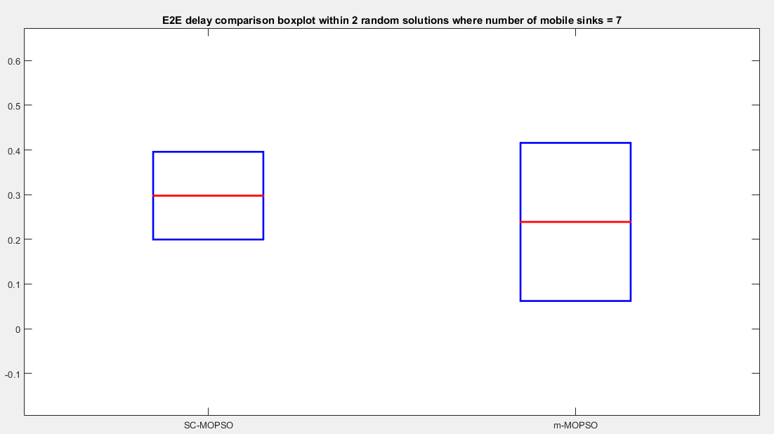
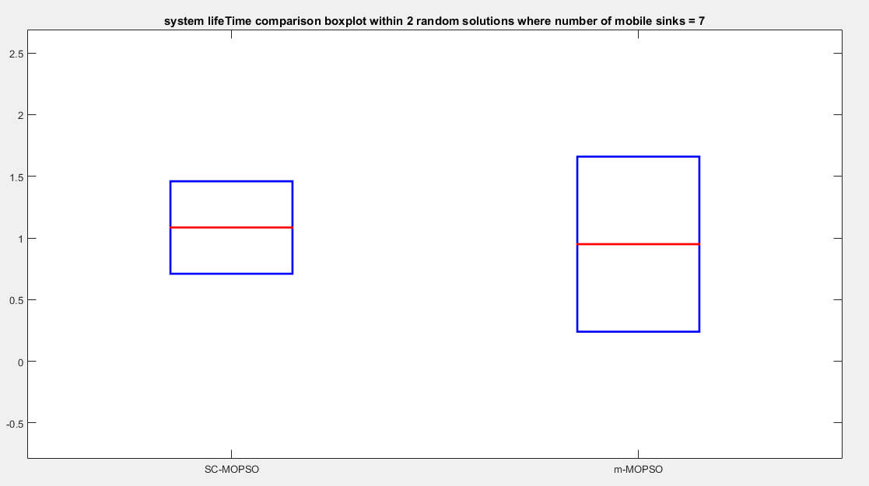

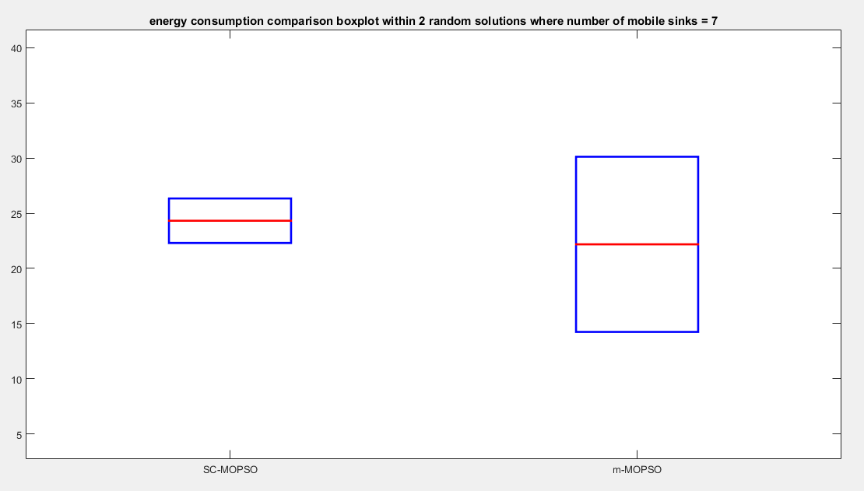

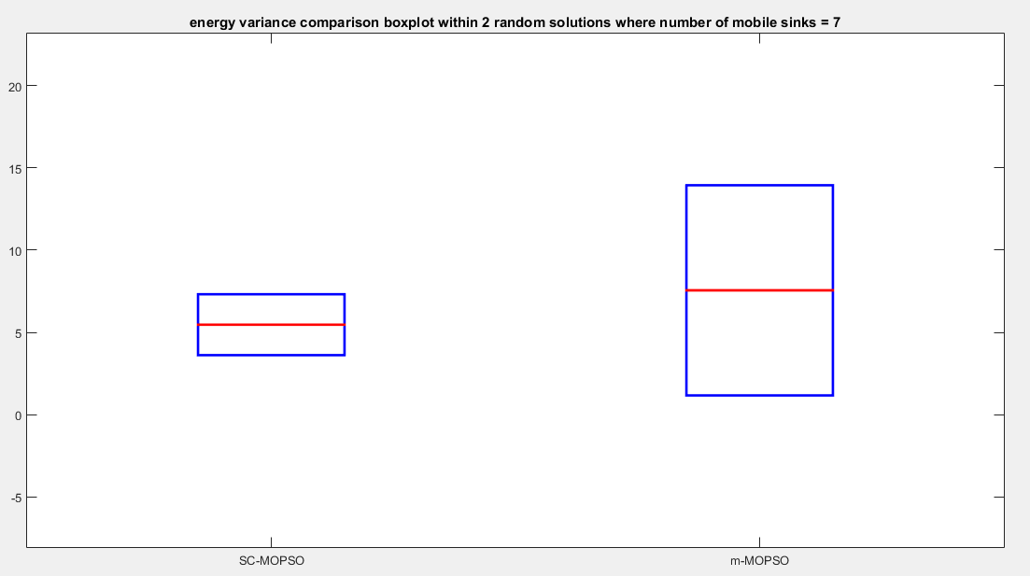

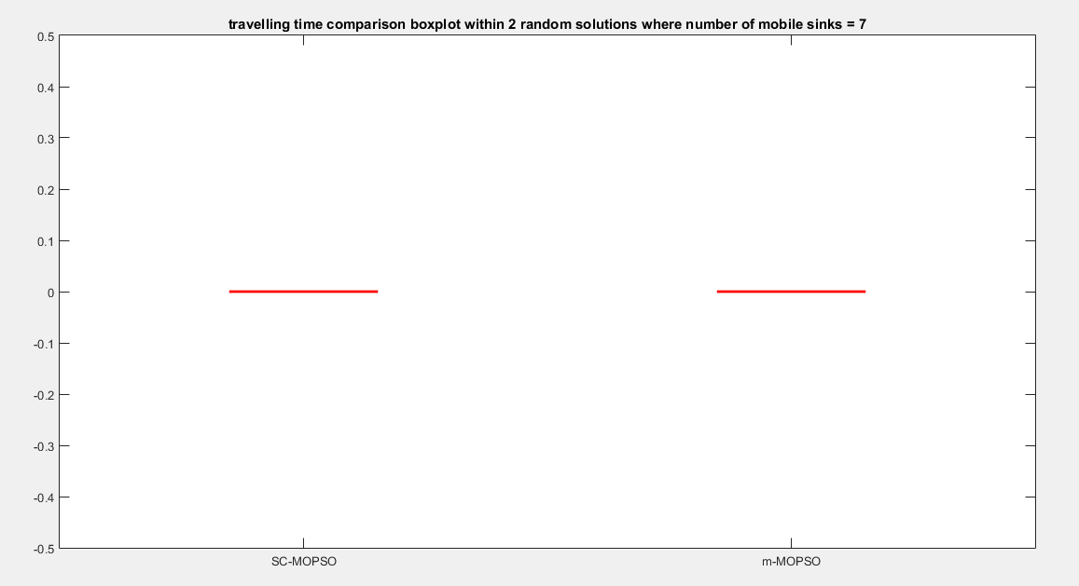

Results summary:
PDR  (from best to worst) | Dropped Ratio  (from best to worst) | E2E Delay  (from best to worst) | Travelling time  (from best to worst) | Energy consumption  (from best to worst) | Energy  Vaiance  (from best to worst) | System Life time  (from best to worst)
m-MOPSO | m-MOPSO | m-MOPSO | 0 | SC-MOPSO | SC-MOPSO | SC-MOPSO
SC-MOPSO | SC-MOPSO | SC-MOPSO | 0 | m-MOPSO | m-MOPSO | m-MOPSO
Cost: 2

PDR  (from best to worst) | Dropped Ratio  (from best to worst) | E2E Delay  (from best to worst) | Travelling time  (from best to worst) | Energy consumption  (from best to worst) | Energy  Vaiance  (from best to worst) | System Life time  (from best to worst)
m-MOPSO | m-MOPSO | m-MOPSO | SC-MOPSO | SC-MOPSO | m-MOPSO | SC-MOPSO
SC-MOPSO | SC-MOPSO | SC-MOPSO | m-MOPSO | m-MOPSO | SC-MOPSO | m-MOPSO
Cost: 3

Cost: 4

PDR  (from best to worst) | Dropped Ratio  (from best to worst) | E2E Delay  (from best to worst) | Travelling time  (from best to worst) | Energy consumption  (from best to worst) | Energy  Vaiance  (from best to worst) | System Life time  (from best to worst)
SC-MOPSO | SC-MOPSO | SC-MOPSO | 0 | SC-MOPSO | SC-MOPSO | m-MOPSO
m-MOPSO | m-MOPSO | m-MOPSO | 0 | m-MOPSO | m-MOPSO | SC-MOPSO

Cost: 5

PDR  (from best to worst) | Dropped Ratio  (from best to worst) | E2E Delay  (from best to worst) | Travelling time  (from best to worst) | Energy consumption  (from best to worst) | Energy  Vaiance  (from best to worst) | System Life time  (from best to worst)
m-MOPSO | SC-MOPSO | SC-MOPSO | 0 | SC-MOPSO | SC-MOPSO | m-MOPSO
SC-MOPSO | m-MOPSO | m-MOPSO | 0 | m-MOPSO | m-MOPSO | SC-MOPSO

PDR  (from best to worst) | Dropped Ratio  (from best to worst) | E2E Delay  (from best to worst) | Travelling time  (from best to worst) | Energy consumption  (from best to worst) | Energy  Vaiance  (from best to worst) | System Life time  (from best to worst)
SC-MOPSO | SC-MOPSO | SC-MOPSO | 0 | SC-MOPSO | SC-MOPSO | SC-MOPSO
m-MOPSO | m-MOPSO | m-MOPSO | 0 | m-MOPSO | m-MOPSO | m-MOPSO
Cost: 6

PDR  (from best to worst) | Dropped Ratio  (from best to worst) | E2E Delay  (from best to worst) | Travelling time  (from best to worst) | Energy consumption  (from best to worst) | Energy  Vaiance  (from best to worst) | System Life time  (from best to worst)
SC-MOPSO | SC-MOPSO | m-MOPSO | 0 | m-MOPSO | SC-MOPSO | SC-MOPSO
m-MOPSO | m-MOPSO | SC-MOPSO | 0 | SC-MOPSO | m-MOPSO | m-MOPSO
Cost: 7

- As we see , SC-MOPSO is superior in most cases .
- SC-MOPSO superiority ratio 58.1 %
- m-MOPSO superiority ratio 36.5 %

- travelling time measure discussing:
- for case of 3 and 2 mobile sinks, we notice that the travelling time has often 0 value, and this may be resulted by the short system life time, and then the simulator will stop before that mobile sink complete its round , resulting not saving the travelling time and keep the initial zero value, but if we review the optimization results we will see that SC-MOPSO has minimum travelling time values, and this gives SC-MOPSO more superiority.
- For case of 4, 5 ,6 and 7 mobile sinks, the mobile sinks number is large and of course, there is no need to more than 1 randivouz point , so the travelling time will keep 0.

- Energy consumption discussing:
- We notice that the long system life time often leads to more energy consumption. However, SC-MOPSO have been superior in terms of system life time and energy consumption in many cases, we also notice that SC-MOPSO is more able to achive load balancing.

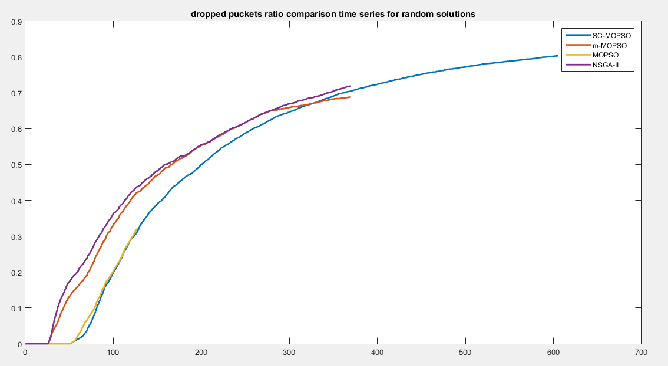
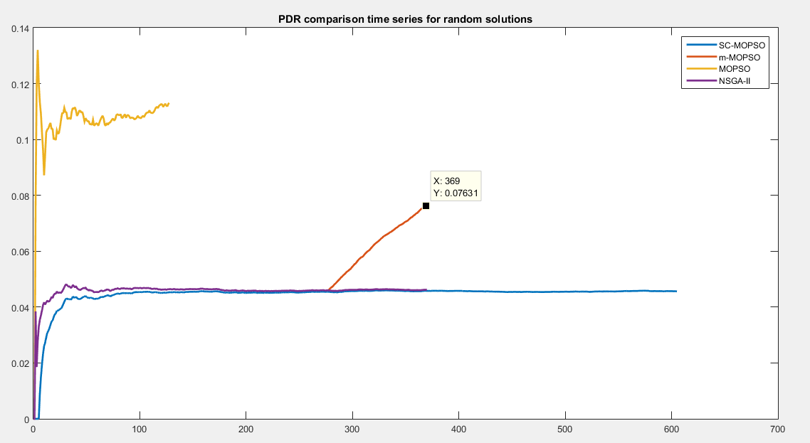
Mesures visulaization as time series:

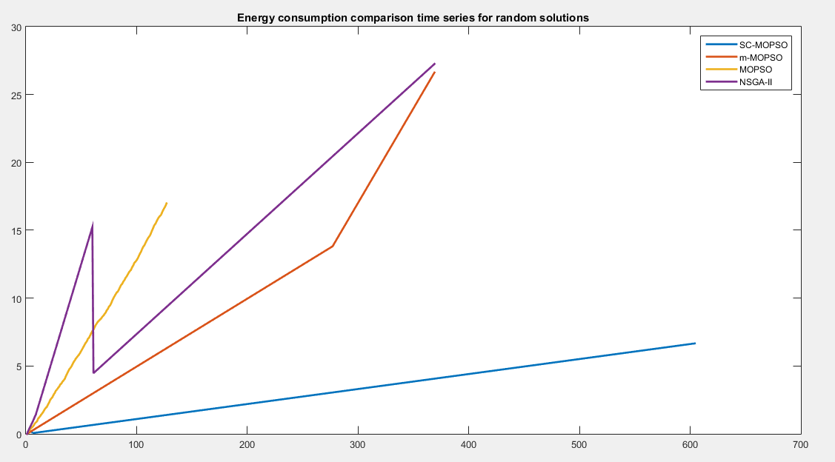
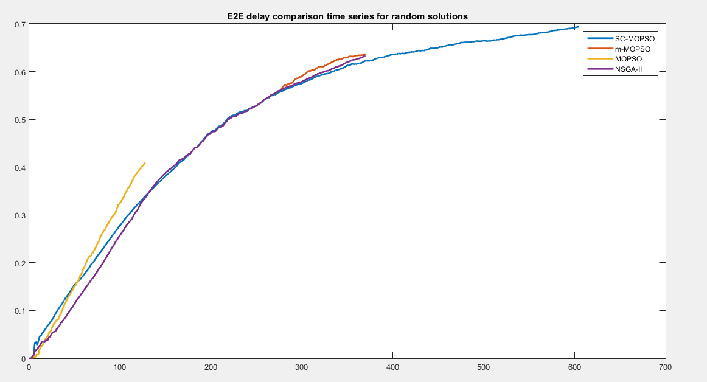

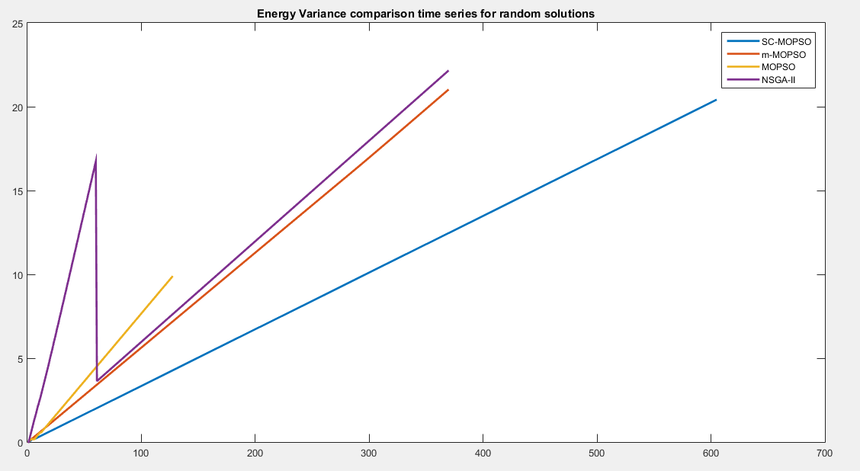
As we see, SC-MOPSO is superior in terms of most measures.
For PDR, although SC-MOPSO is not superior, but it has longer system life time and this makes it better.

Conclusion:
- SC-MOPSO has introduced the best performance in the simulation and the optimized results
- I thing that if we executed the optimization algorithms with more iterations, our algorithm will introduce better performance, and if we make the mobile sinks numbers range and randivouz points range bigger , it will more strongly illustrate SC-MOPSO superiority

